# CS 340 README Template

*Use this template to complete your README file. When completing the template, keep the headings as they are so that your document has a clear organization. Remove the italicized prompt text after you have completed each section for a polished final document.*

## About the Project/Project Title

*Provide a little information about your project or an overview that explains* ***what*** *the project is about.*

-This project allows users to access an animal shelter database to create, read, update, and delete animals from the application. It also attempted to create a web based interface for the user as well.

## Motivation

*This is a short description of the motivation behind the creation and maintenance of the project. This should explain* ***why*** *the project exists.*

-The motivation behind this was to test my abilities to use the CRUD methods through MongoDB, Python, and Jupiter’s Notebook.

## Getting Started

*This is an example of how you may give instructions on setting up your project locally: “To get a local copy up and running, follow these simple example steps.”*

1. Import aac_shelter_outcome.csv into the Linux terminal.
2. Verify the dataset loaded correctly into the mongo shell.
3. Authenticate an admin account and aac_user account to access the database.
4. Utilize python to run the application.
5. Create a web based platform to host the database using jupyters notebook

## Installation

*List the tools you need to use the software and how to install them.*

1. MongoDB to access the database
2. Python
3. Jupyter’s Notebook

## Usage

*Use this space to show useful examples of how your project works and how it can be used. Be sure to include examples of your code, tests, and screenshots.*

### Code Example

* The code is designed to allow the user to add, edit, and delete animals in the shelter database. You would first need to start mongo and load the python files into it. Then you could test it by using something similar to print(animals.create(String) and see if the animal added worked.

### Tests

* The code was tested by querying added animals to the database. It would look something like this query = animals.read({“name” : “NAME”})

### Screenshots

*Provide screenshots that demonstrate your work.*

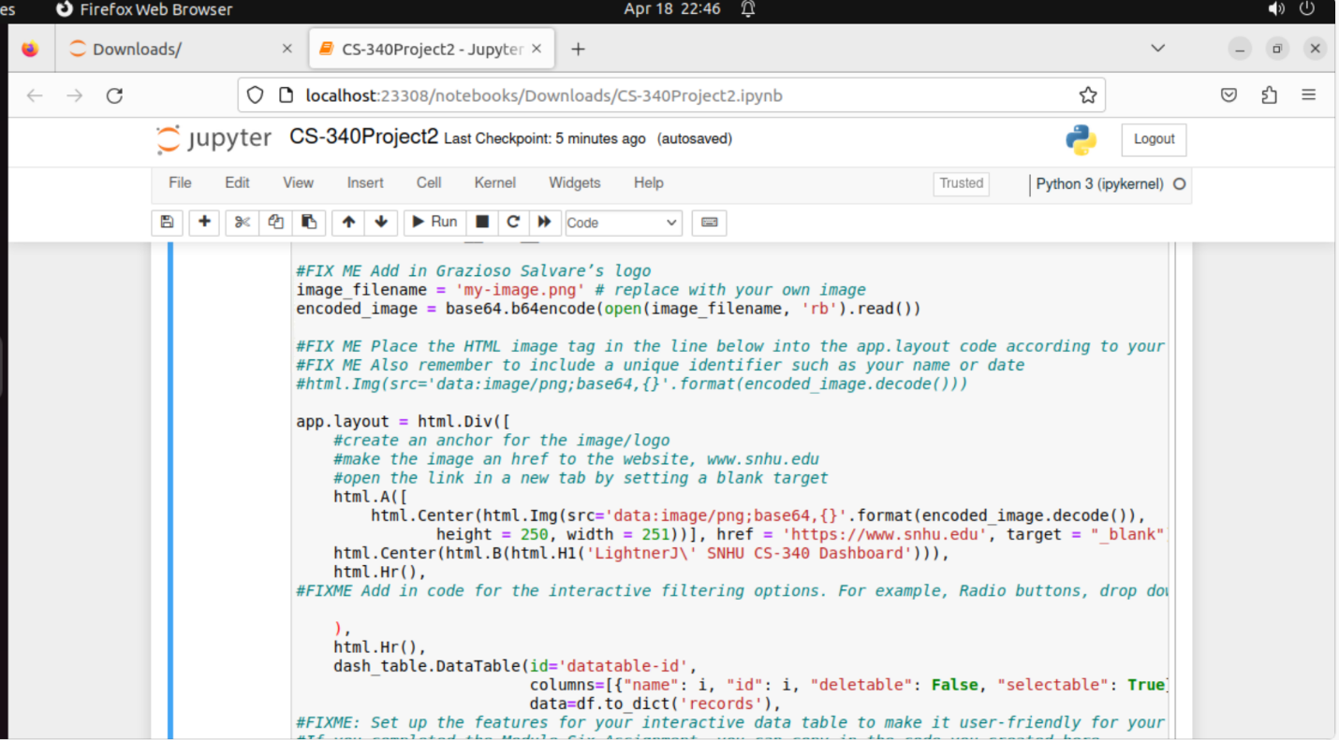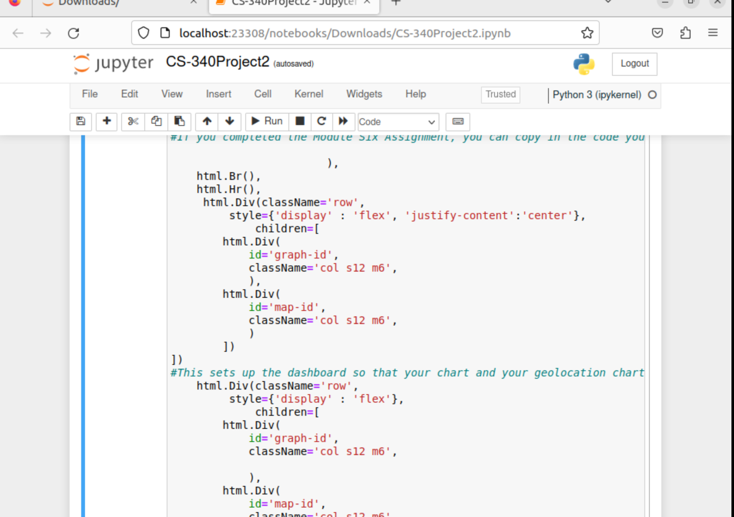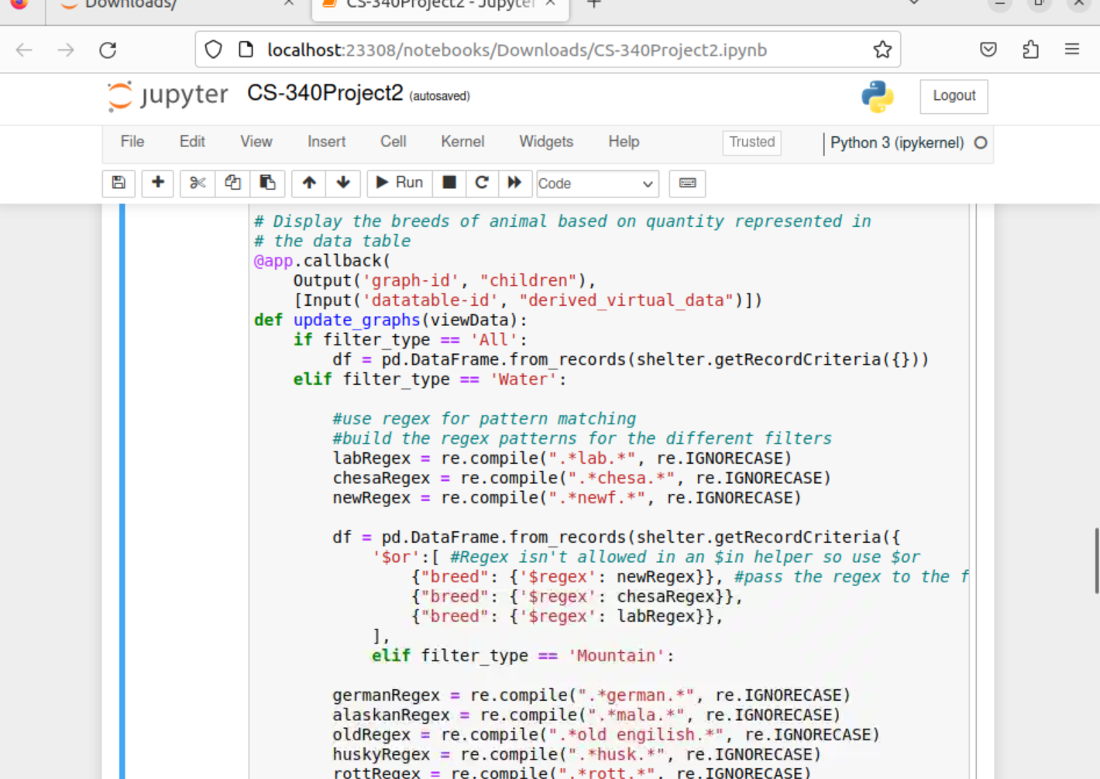

*.*

## Contact

Your name: James Lightner